District 3 Answer Key
3.1 Answer Key | 3.2 Answer Key
1. D  2. A  3. B  4. D  5. D  6. B  7. A  8. A  9. A  10. Ionic = transfer of electrons between metal and nonmetal. ex. FrF. covalent = sharing of electrons between two non-metals. ex. ClF  11. SrF₂  12.  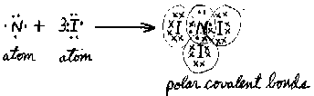  13.  14. BaCl_{2\}  15. See Mr. Astor  16.  17. O=C=O  18. ANS:  19. H – C = C – H | 1. a) Nitrogen and carbon need one more bond  b) Hydrogen cannot form a double bond  c) Fluorine cannot form a double bond with oxygen  d) Boron only has 3 valence electrons  e) Carbon and oxygen should have a double bond  2. See Mr. Astor

