District 3 Practice Problems
1. The formation of a chemical bond involves:
A. only the protons;
B. protons and electrons
C. electrons and neutrons
D. only the electrons.

2. When elements combine to form compounds
A. only the outermost electrons of the atoms are involved
B. all the electrons of the atoms are involved
C. the protons and electrons are involved
D. only the protons are involved.

3. What takes place when a chemical bond forms between two atoms?
A. The forces of repulsion are greater than the forces of attraction.
B. A pair of electrons is simultaneously attracted by two nuclei.
C. An increase in potential energy results.
D. The nuclei of the atoms become stable.
E. The nuclei of the atoms become unstable.

4. The number of bonds formed by an atom is most closely associated with
A. its atomic mass
B. the number of electrons in the atoms
C. the number of electron shells
D. the number of electrons in the outer shell.

5. During chemical reactions, each atom tends to
- lose electrons
- gain electrons
- lose an outer shell
- gain a complete shell.

6. Which description applies to compound BY if elements B and Y have a large difference in electronegativity?
- Its atoms repel each other
- The bond is primarily ionic
- bond is primarily metallic
- The bond is coordinate covalent.

7. The formula Sr(ClO₃)₂ represents
- a molecule consisting of three ions;
- a molecule consisting of five atoms
- ionic bonds between three different elements
- a polyatomic ion with a valence number of –2.

8. Which bond has the greatest degree of ionic bonding?
A) Li-Br B) F-F C) H-Cl D) S-O

9. An example of a cation is:
A) Ca⁺²; B) SO₄⁻²; C) NO₃⁻; D) Cl⁰; E) CH₄.

10. Contrast ionic bonding and covalent bonding and give one compound to
illustrate your arguement.

11. Write the ionic compound that would form from Sr and F

12. Draw a Lewis Structure of NI₃.

13. Use an Lewis Structure to show the formation SSe.

14. Write an ionic equation for a molecule that forms when Ba and Cl combine.
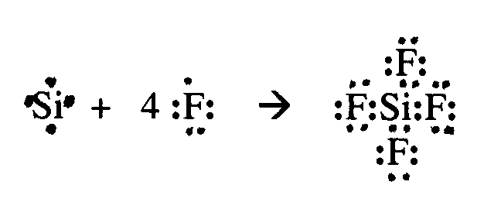

15. Draw a Lewis Structure of S₂.

16. Draw a Lewis Structure of SBr₂.

17. Draw a Lewis Structure of CO.

18. Fluorine has the atomic number 9 and the atomic mass 19.
Draw the electron-dot diagram for:
a) fluorine atom
b) fluoride ion.

19. Draw the Lewis structure for C₂H₂

